

CSA0501-DATABASE MANAGEMENT SYSTEMS

LAB EXPERIMENTS DATE:12 /08/2026

EXPERIMENT 18– HIGH LEVEL LANGUAGE EXTENSION WITH CURSORS

AIM: To implement Cursors using programs in MySQL.

PROCEDURE:
- Select the pet_management database.
- Declare an explicit cursor to retrieve pet names from pet_details.
- Open the cursor and fetch records one by one.
- Build a list of pet names using the fetched values.
- Continue fetching until all records are processed.
- Close the cursor after completing the operation.
- Display the final pet name list.

PROGRAM:

DELIMITER //
CREATE PROCEDURE build_pet_list(INOUT pet_list VARCHAR(4000))
BEGIN
DECLARE v_finished INTEGER DEFAULT 0;
DECLARE v_pet_name VARCHAR(100) DEFAULT '';
DECLARE pet_cursor CURSOR FOR
SELECT pet_name FROM pet_details;
DECLARE CONTINUE HANDLER FOR NOT FOUND
SET v_finished = 1;
OPEN pet_cursor;
get_pet: LOOP
FETCH pet_cursor INTO v_pet_name;
IF v_finished = 1 THEN
LEAVE get_pet;
END IF;
SET pet_list = CONCAT(pet_list, v_pet_name, ';');
END LOOP get_pet;
CLOSE pet_cursor;
END //
DELIMITER ;

OUTPUT:
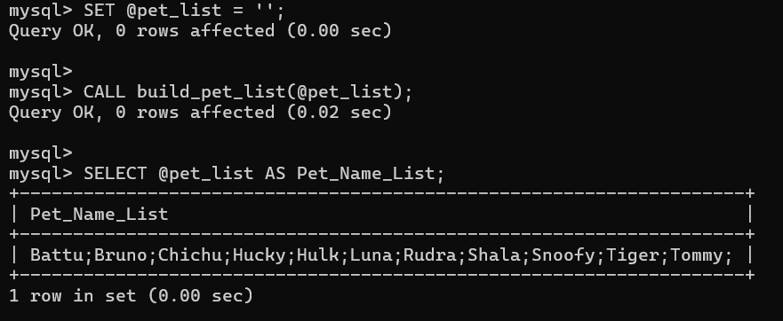

RESULT: The Cursor program using MySQL was successfully executed, and the pet names were retrieved row by row and displayed as a list.

